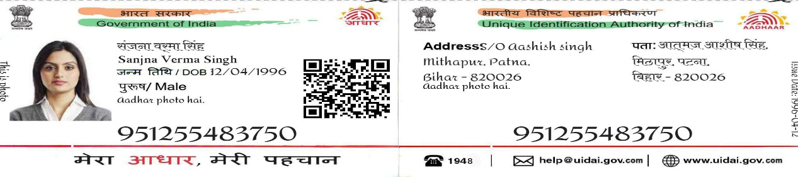



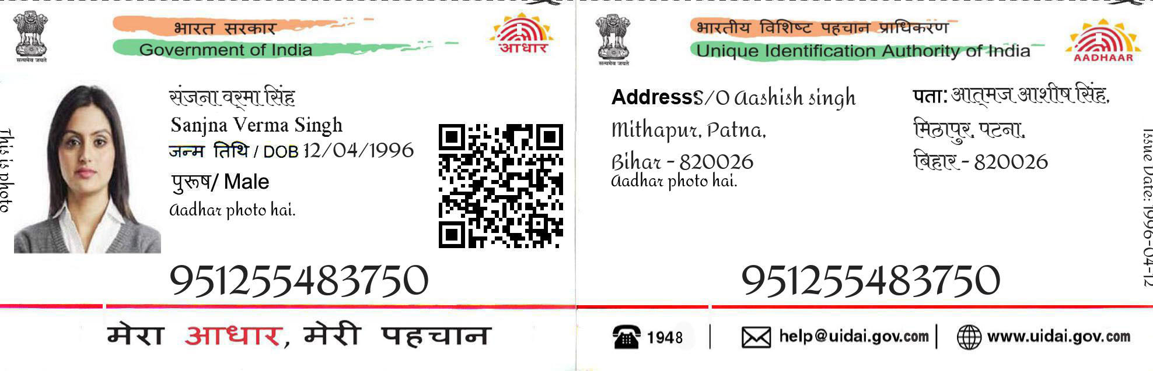

Name-Siya Yadav

DOB-2/10/2007

Gender-Female

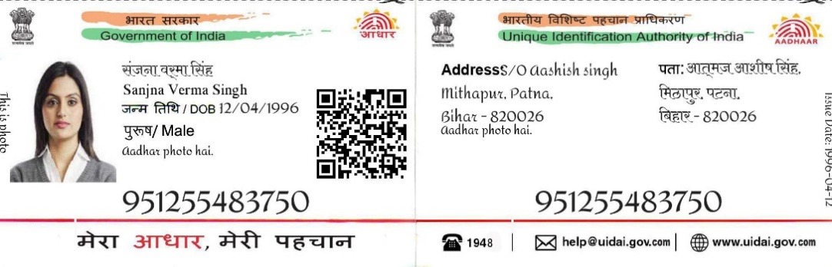

9546 9056 5439



Address S/O Yash Yadav

Dwarka , Kirti Nagar

NEW DELHI 110056

9546 9056 5439

44



help uidia gov